How to rebuild the master database 2000

1. Shutdown Microsoft® SQL Server™ 2000, and then run Rebuildm.exe. This is located in the Program Files\Microsoft SQL Server\80\Tools\Binn directory.

2. In the Rebuild Master dialog box, click Browse.

3. In the Browse for Folder dialog box, select the \Data folder on the SQL Server 2000 compact disc or in the shared network directory from which SQL Server 2000 was installed, and then click OK.

4. Click Settings. In the Collation Settings dialog box, verify or change settings used for the master database and all other databases.

Initially, the default collation settings are shown, but these may not match the collation selected during setup. You can select the same settings used during setup or select new collation settings. When done, click OK.

5. In the Rebuild Master dialog box, click Rebuild to start the process.

The Rebuild Master utility reinstalls the master database.

### Rebuilding the System Databases

If your master database has ceased functioning, you cannot recover quite this easily. In this case, you must rebuild the system databases from scratch (or possibly reinstall SQL Server 2000). To rebuild the system databases, use the Rebuildm.exe utility located in the C:\Program Files\Microsoft SQL Server\Tools\Binn folder. When you use the Rebuildm utility, you use the original data files for each of the system databases to rebuild each system database to their original condition in the Rebuild Master dialog box. You must have the original installation files available, either on a local drive or on a network drive. See Figure 9.29.

Remove the Read-only attribute from the original installation files, orthe Rebuildm utility will fail.

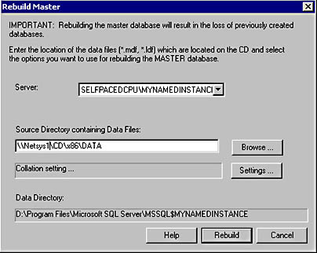

Figure 9.29

Rebuilding the master database.

Click the Rebuild button to begin the process. You receive a warning in a Rebuild Master dialog box that you are about to rebuild and overwrite all of your system databases. See Figure 9.30.

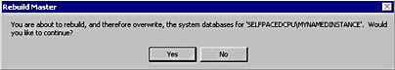

Figure 9.30

The Rebuild Master warning dialog box.

After the rebuild is complete, you will need to restore your master database in the manner described earlier. Next, restore each system database, particularly the msdb database. If you have customized the model database, restore it. If you are using replication, you will need to restore the distribution database. Replication is covered in Chapter 15. Finally, you may need to restore or reattach any system databases that were affected by the failure of the system databases.

### Restoring the Master Database

If your master database is functioning but damaged in some fashion (such as the deletion of all logins), you can restore the master database using the most recent full database backup of the master database. Any changes to the master database since the most recent database backup will be lost. You should script database objects when you create them and save the scripts. You should also mirror the system databases using RAID 1 where possible.

To restore the master database, start SQL Server 2000 in single- user mode with the -m option in the Command Prompt window or from the Run dialog box.

Sqlservr -m

The preceding command starts SQL Server 2000 as an application in a command-prompt window. The text you see when you start SQL Server 2000 as an application is the same text you see in the SQL Server error log. See Figure 9.27.

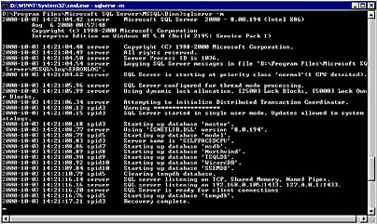

Figure 9.27

Starting SQL Server 2000 as an application in a command-prompt window.

Next , start SQL Query Analyzer and restore your most recent backup of the master database using the same commands you use to restore any user database.

RESTORE DATABASE master FROM MasterFullBackup

The preceding example restores the master database from the MasterFullBackup backup device. See Figure 9.28.

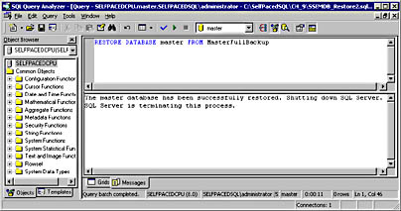

[**Rebuild MSDB Database**](http://sudeeptaganguly.wordpress.com/2012/06/19/rebuild-msdb-database/)

1. Stop all the SQL Server services & start the command prompt with elevated administrative privilege & execute the following command:   
   NET START MSSQLSERVER /T3608
2. Once you start the SQL Server with trace flag 3608, you will be able to detach the msdb database. To do that, execute the following command in SQLCMD mode:   
   SQLCMD -E -S DBS03 -dmaster -Q"EXEC sp_detach_db msdb"
3. Rename the msdb data file, and execute the **instmsdb.sql** file from the install folder, as shown below:   
   SQLCMD -E -S DBS03 -i"E:\SQL Server\MSSQL10_50.MSSQLSERVER\MSSQL\Install\instmsdb.sql" -o"E:\instmsdb.out"
4. Review the instmsdb.out for any errors and re-apply the service packs.
5. Stop the SQL Server.
6. Start the SQL Server normally

[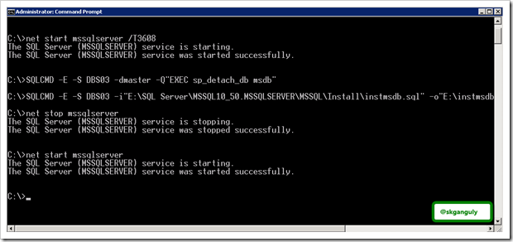](http://sudeeptaganguly.files.wordpress.com/2012/06/stepstofollow.png)

Since I was able to connect to the instance without any error, I stopped the SQL Server instance and copy all the system databases files. Later I restarted the SQL Server Agent and the instance was online.

Rebuilding master database in SQL Server 2005

Execute the following at the command prompt:  
  
***START /WAIT <media drive and path>\setup.exe /qn INSTANCENAME=<INSTANCE NAME> REINSTALL=SQL_Engine REBUILDDATABASE=1 SAPWD=<STRONG SA PASSWORD>***  
  
Note: <INSTANCE NAME> is just the SQL Server INSTANCE name or “MSSQLSERVER” if the default instance.

[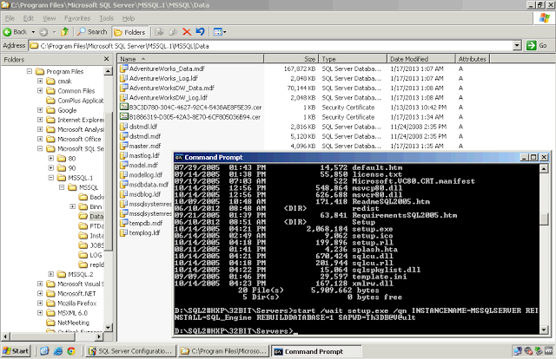](http://4.bp.blogspot.com/-3cdknEJYNzk/UPeuVm9idWI/AAAAAAAABa4/ehh-mxfULgY/s1600/5.png)

Setup will take few minutes to complete. Once complete check <SQL SERVER>\DATA folder and verify the databases are present. Also, review the SUMMARY.TXT file for any issues. The file is located in C:\Program Files\Microsoft SQL Server\90\Setup Bootstrap\LOG folder.

[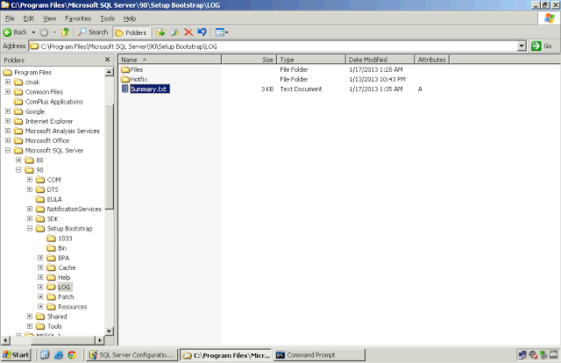](http://1.bp.blogspot.com/-fs7DharTTvY/UPeuVtDRDxI/AAAAAAAABaw/x4Y0BoED5EU/s1600/51.png)

Sample Summary.txt file:

[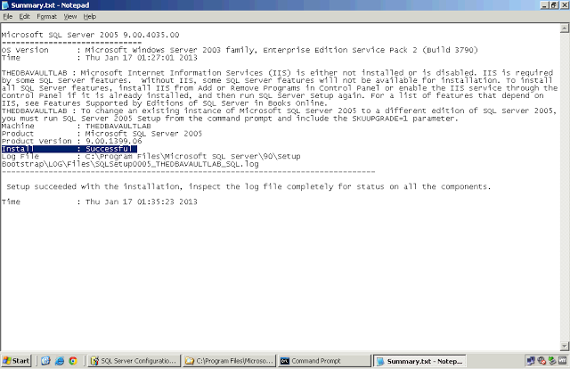](http://2.bp.blogspot.com/-QAAo3_Kzcfs/UPeuWA_S3LI/AAAAAAAABbE/GWcf-WV2xt8/s1600/6.png)

Step 2:  
  
Test the server by starting the instance in single-user mode and connect using SQLCMD  
  
***C:\>net start MSSQLSERVER /m***  
[note: use MSSQL$<instance name> for a named instance]

[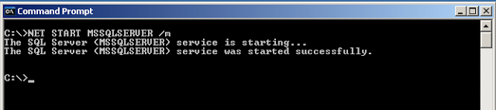](http://1.bp.blogspot.com/-D46G-JC8v1E/UPbzpEvC2zI/AAAAAAAABZU/ZqJWmtHOGc4/s1600/Single-User+Command.png)

***C:>\sqlcmd -S <server name>***  
  
Log out of the server and shut down the instance  
***C:\>net stop MSSQLSERVER***  
  
Step 3:  
  
Restore MASTER Database  
  
Restore MASTER database using your latest SQL Server full database backup. This MUST be run in single user mode.   
  
In the previous step we logged out and shutdown the instance. Start the SQL instance in single-user mode via command prompt, connect using SQLCMD and restore master database. See steps below.  
  
***C:\>net start MSSQLSERVER /m***  
***C:>\sqlcmd -S <server name>***  
**1 - *restore database master from disk='C:\TheDBAVault\Backup\SystemDB\master.bak' with replace***  
**2 - *GO***  
  
SQL Server instance will automatically shutdown after restore. With the successful restoration, the instance is in the configuration as of the last MASTER database backup. If there were any instance-wide changes after the last backup (any user created database or logins created, will have to be recreated manually, users databases will have to be reattached)  
  
Complete the system database restoration process. Restore MODEL and MSDB databases from the last good backup. MSDB is important because it contains ALL job scheduling information and history, Maintenance Plan data and history, backup and restore history, and DBMAIL settings among other things. It can also contain SSIS package stores.  
  
For all system database restores:

1. Start the SQL Server instance using SQL Server Configuration Manager. DO NOT start SQL AGENT or any other services.
2. Connect via command line using SQLCMD
3. Restore model and MSDB from last full backup.  Apply log backups if applicable.
4. Use the REPLACE option
5. If restoring transaction logs, use NO RECOVERY for each restored backup. Once all backups in the backup set are restored in the proper order, restore the database with RECOVERY to bring it on-line.

Recreate the msdb database in SQL Server 2005

Put MSSQL into single user mode   
  
1.Click -> START -> Microsoft SQL Server 2005 -> Configuration Tools – > SQL Server Configuration Manager  
2.Right click on SQL Server and choose Properties  
3.Click on the Advanced tab. Under Startup Parameters you will be adding the   
following parameters to the beginning of the string: -m;-c;-T3608;  
  
  
  
2.Restart SQL Server  
  
  
3.Connect to SQL server through the Management Console or through command prompt using sqlcmd.   
From this point on we will be using TSQL to issue the commands so click the New Query button on the top left. At this point you should be in the master database inside the query window.  
  
Stop reporting or integration services it might stop you to connect in single user mode.  
  
  
4.Detach the MSDB database using the following commands:  
  
use master  
go  
sp_detach_db ‘msdb’  
go   
  
  
5.We need to move (or rename, I prefer moving them) the existing MDF and LDF files for the MSDB database so that we can recreate it.   
  
  
1.Usually these files are located in the following directory:  
  
C:\Program Files\Microsoft SQL Server\MSSQL.1\MSSQL\Data  
  
Your’s might differ.  
  
2.Move (or rename) the MSDBDATA.mdf and MSDBLOG.ldf files.  
  
  
  
6.Back to the Management Studio. Open up the instmsdb.sql file in a new query window. This file is usually located in the following directory:  
  
C:\Program Files\Microsoft SQL Server\MSSQL.1\MSSQL\Install  
  
  
7.Execute the file. If you see any errors about xp_cmdshell, just ignore them. They are common and the script will take care of it.  
  
  
8.At this point you should have your MSDB database restored. The only thing left is cleanup.  
  
  
  
9.Execute the following command to make sure that xp_cmdshell is once again set to disable for security reasons:  
  
EXEC sp_configure ‘show advanced options’, 1  
GO  
RECONFIGURE WITH OVERRIDE  
GO  
EXEC sp_configure ‘xp_cmdshell’, 0  
GO  
RECONFIGURE WITH OVERRIDE  
GO  
  
  
10.Shutdown SQL Server  
  
  
11.Go back into your Startup Paremeters for your server in the SQL Server Configuration Manager and removed the -c;-m;-T3608 parameters we added earlier.  
  
  
12.Restart SQL Server  
  
Everything should be cool at this point and you’ll be able to recreate any Maintenance Plans and Jobs.

Rebuilding master database in SQL Server 2008

**Please try with SQL Server service account.**

Recently one of my instances was corrupted and I was unable to restart SQL Server. I did the following steps to get it back. First I checked the SQL Server ERRORLOG. Please go through the following steps.

**Step1: Check the error log where it is showing master was corrupted.**

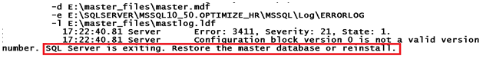

**Step2:** Rebuild system databases from command prompt**.** Go to the following  path and run setup as follows

C:\Program Files\Microsoft SQL Server\100\Setup Bootstrap\SQLServer2008R2

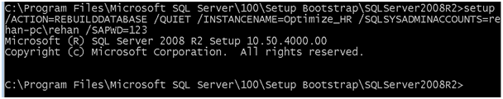

setup.exe

/QUIET

/ACTION=REBUILDDATABASE

/INSTANCENAME=*instance_name*

/SQLSYSADMINACCOUNTS= *accounts*

[/SAPWD=*password*]

[/SQLCOLLATION=*collation_name*]

**Step3:** Once the above command runs successfully, check in the summary.txt file as follows and look at the Requested action.

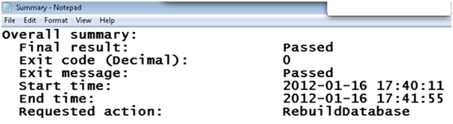

**Step4:** Start SQL Server service.

http://www.codeproject.com/KB/database/537811/master_rebuild4.png

**Step5:** Connect to the instance. But you cannot see any user defined databases. The rebuilding process has created a fresh master database so there are no other databases and all previous configuration values are lost.

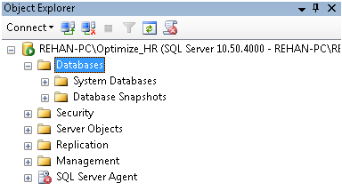

**Step7:** Now we can restore the master database to get the previous configuration settings. Go to command prompt and run server in single user mode as follows

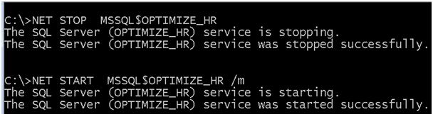

**Step8:** Connect to the instance and take new query to restore master database. Once we restore master database then we can get all the previous configuration values including user defined databases.

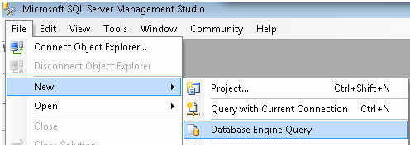

**Step9:** Click on Connect button and connect to the instance as follows

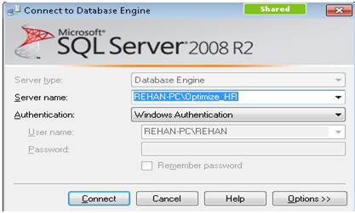

**Step10:** Restore master database as follows

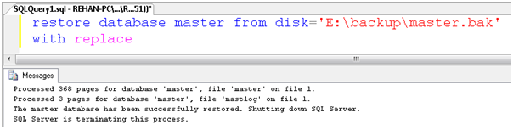

**Step11:** Restart SQL Server instance in multi user mode and connect to SQL        Server Management Studio. We can see all user databases as follows.

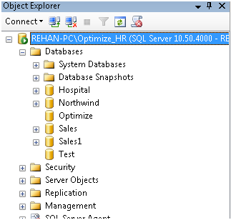

Happy learning!

Recreate the msdb database in SQL Server 2008

1. Restart SQL Server using: net **start MSSQLSERVER /f /T3608 /m /c**
2. Connect to SQL server through the Management Console. From this point on we will be using TSQL to issue the commands so click the **New Query** button on the top left. At this point you should be in the master database inside the query window.
3. Detach the MSDB database using the following commands:  
   **use master  
   go  
   sp_detach_db ?msdb?  
   go**
4. We need to move (or rename, I prefer moving them) the existing MDF and LDF files for the MSDB database so that we can recreate it.
   1. Usually these files are located in the following directory:  
      **C:\Program Files\Microsoft SQL Server\MSSQL.1\MSSQL\Data**  
      Your?s might differ.
   2. Move (or rename) the **MSDBDATA.mdf and MSDBLOG.ldf** files.
5. Back to the Management Studio. Open up the **instmsdb.sql** file in a new query window. This file is usually located in the following directory:  
   **C:\Program Files\Microsoft SQL Server\MSSQL.1\MSSQL\Install**
6. Execute the file. If you see any errors about xp_cmdshell, just ignore them. They are common and the script will take care of it.
7. At this point you should have your MSDB database restored. The only thing left is cleanup.
8. Execute the following command to make sure that xp_cmdshell is once again set to disable for security reasons, and that Agent XPs are enabled:  
   **EXEC sp_configure ?show advanced options?, 1  
   GO  
   RECONFIGURE WITH OVERRIDE  
   GO  
   EXEC sp_configure ?xp_cmdshell?, 0  
   GO  
   RECONFIGURE WITH OVERRIDE  
   GO**

**EXEC sp_configure ?show advanced options?, 1**

**GO  
RECONFIGURE WITH OVERRIDE  
GO  
EXEC sp_configure ?**Agent XPs?**, 1  
GO  
RECONFIGURE WITH OVERRIDE  
GO**

Restart SQL Server in normal mode

Rebuild all your jobs and set up database mail etc

Rebuilding master database in SQL Server 2008 R2

I have came across these question very frequently in SQL Server Database Administration workshops I have conducted. So thought of writing my own blog for it.

1. SQL Server 2008 R2 is crashed and then unable to restart the SQL Server 2008 R2 instance.
2. There is an unexpected shutdown of SQL Server 2008 R2 instance.
3. In the SQL Server Error Logs found an entry "Cannot restore Master database"
4. What is the action plan in the event of SQL Server 2008 R2 instance failure?
5. How quickly the SQL Server 2008 R2 instance can be brought back online?
6. Is there any utility available of this? or need to reinstall SQL Server 2008 R2?

Well, the solution for it depends on following:

➢  Restore from the previous backups of System database.

➢  Rebuild System databases.

I will address here the procedure for How to rebuild system databases. Here are the Steps for Rebuilding System databases:

1. Insert the SQL Server 2008 R2 installation media into the disk drive.

2. Goto the following location   
E:\Softwares\SQL Server 2008 R2\SQLFULL_x64_ENU\Setup.exe or search for setup.exe locally in F:\Program Files\Microsoft SQL Server\100\Setup Bootstrap\Release\setup.exe

[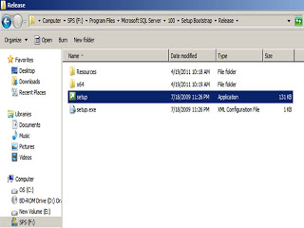](http://1.bp.blogspot.com/-3Mc_lUjnu-E/TcAz7Cj690I/AAAAAAAAB3U/exAfs7eq4YQ/s1600/SQL+Server+2008+R2+setup+location.jpg)

[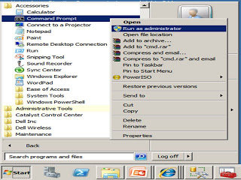](http://1.bp.blogspot.com/-iYptZldYDvM/TcAz-olUTtI/AAAAAAAAB3Y/PiuzVmDkgk8/s1600/Command+Prompt.jpg)

3. Launch Command Prompt in administrator mode.

Click on Start-> All Programs -> Accessories -> Command Prompt. Right Click on Command Prompt and select Run as Administrator

4. Enter the following command in the Command Prompt Window  
  
Setup /QUIET /ACTION=REBUILDDATABASE /INSTANCENAME=MSSQLSERVER /SQLSYSADMINACCOUNTS=[Priti\Administrator]

|  |  |
| --- | --- |
| **Options** | **Description** |
| /INSTANCENAME=MSSQLSERVER | Name of the instance. MSSQLSERVER is the name of the default instance. |
| /SQLSYSADMINACCOUNTS=[Priti\Administrator] | Windows groups or individual accounts to provision as sysadmin. |
| [/SAPWD=password] | Is optional and required if you have enabled mix authentication i.e. [SQL Server and Windows Authenticaton] |
| [/SQLCOLLATION=collation_name] | Is optional. Provide this parameter if you want to use different collation than used at the time of installation. |

6. Examine the Summary.txt log file to verify that the process completed successfully. This file is located at F:\Program Files\Microsoft SQL Server\100\Setup Bootstrap\Logs.

7. This new feature is different from previous versions of SQL Server is that the system databases files we use to rebuild the current system databases do not come from the original installation media. They come from the installation folder on your local computer i.e. F:\Program Files\Microsoft SQL Server\MSSQL10.MSSQLSERVER\MSSQL\Binn\Templates

In this directory you will find master, model, and msdb database and log files that were copied from your installation source as part of setup.

The process of rebuilding the system databases copies these files into the **DATA** directory to obtain your new system databases. This is a wonderful enhancements for rebuilding system databases because the original installation media is not required.

Recreate the msdb database in SQL Server 2008 R2

***CAUTION****: Rebuilding the msdb database using the instmsdb script will eliminate all the information stored in msdb such as jobs, alert, operators, maintenance plans, backup history, Policy-Based Management settings, Database Mail, Performance Data Warehouse, etc.*

1. Stop all services connecting to the Database Engine, including SQL Server Agent, SSRS, SSIS, and all applications using SQL Server as data store.
2. Start SQL Server from the command line using the command:  
   **NET START MSSQLSERVER /T3608**  
   For more information, see How to: Start an Instance of SQL Server (net Commands).
3. In another command line window, detach the msdb database by executing the following command, replacing <servername> with the instance of SQL Server: **SQLCMD -E -S<servername> -dmaster -Q”EXEC sp_detach_db msdb”**
4. Using the Windows Explorer, rename the msdb database files. By default these are in the DATA sub-folder for the SQL Server instance.
5. Using SQL Server Configuration Manager, stop and restart the Database Engine service normally.
6. In a command line window, connect to SQL Server and execute the command:  
   **SQLCMD -E -S<servername> -i”C:\Program Files\Microsoft SQL Server\MSSQL10_50.MSSQLSERVER\MSSQL\Install\instmsdb.sql” -o” C:\Program Files\Microsoft SQL Server\MSSQL10_50.MSSQLSERVER\MSSQL\Install\instmsdb.out”**  
   Replace <servername> with the instance of the Database Engine. Use the file system path of the instance of SQL Server.
7. Using the Windows Notepad, open the instmsdb.out file and check the output for any errors.
8. Re-apply any service packs or hotfix installed on the instance.
9. Recreate the user content stored in the msdb database, such as jobs, alert, etc.
10. Backup the msdb database.

Restore Master & MSDB databases form the Backup file

I have full backup of Master and MSDB. My Master and MSDN databases got corrupted or i did some major changes and i want to rollback. Since i have backup i can restore the system database from the backup.  
  
**High level Steps**  
  
(a) Stop and Start the SQL Server Database Engine in Singe User Mode  
(b) Restore the Master Database from SQLCMD prompt  
(c) Start the SQL Server Database Engine  
(d) Restore MSDB Database  
  
  
Windows Start -- Run – Services.MSC --- Enter  
  
You will get this window  
[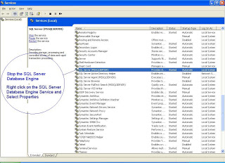](http://2.bp.blogspot.com/_4wBIz276vTw/SLf3_nLSkBI/AAAAAAAAAIo/6sDS03nZ2Z4/s1600-h/Sysdb1.JPG)  
  
  
[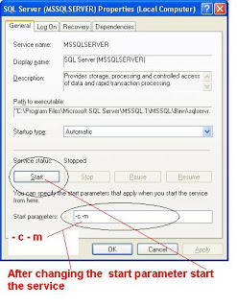](http://1.bp.blogspot.com/_4wBIz276vTw/SLf4K55YJkI/AAAAAAAAAIw/Wri5Oki7c-U/s1600-h/Sysdb2.JPG)  
  
Restore the Master Database from Command Prompt  
  
Windows --- Start --- Run --- CMD --- Enter  
[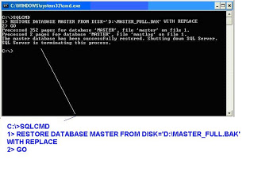](http://1.bp.blogspot.com/_4wBIz276vTw/SLf4Qv2RNSI/AAAAAAAAAI4/OObTtU4n7XU/s1600-h/Sysdb3.JPG)  
  
**-- If the Screen is not readable this is the command and the result**  
  
C:\>SQLCMD  
1> RESTORE DATABASE MASTER FROM DISK='D:\MASTER_FULL.BAK' WITH REPLACE  
2> GO  
Processed 352 pages for database 'MASTER', file 'master' on file 1.  
Processed 2 pages for database 'MASTER', file 'mastlog' on file 1.  
The master database has been successfully restored. Shutting down SQL Server.  
SQL Server is terminating this process.  
  
C:\>  
  
The message says that you have successfully restored Master database.  
  
Note : You have to restart the Database Engine Now  
  
  
[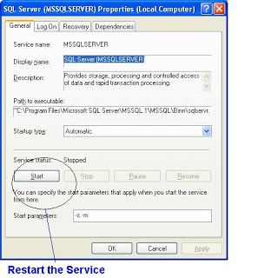](http://1.bp.blogspot.com/_4wBIz276vTw/SLf4lOGjXYI/AAAAAAAAAJA/s3DoS9r9e6k/s1600-h/Sysdb4.JPG)  
  
  
**Restore MSDB Database from Management Studio**  
  
RESTORE DATABASE MSDB FROM DISK='D:\MSDB_FULL.BAK' WITH REPLACE